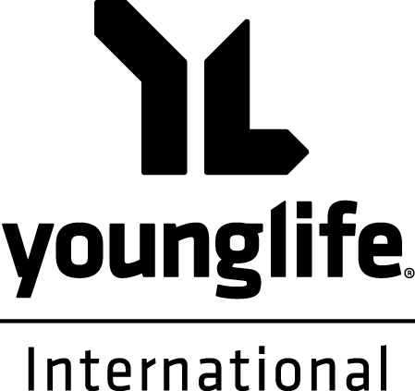
Financial Support Form
I would like to give financially toward the work of Young Life International by making a monthly / quarterly / annual / one-off gift of £100 / £50 / £20 / £10 / Other £ [please select] starting on: __/__/__ (DD/MM/YY).
I would like this work to fund:
☐ a particular area (Name of Area or Ministry _______________________ )
☐ the work of a particular Staff Person
(Name of Staff Person _____________________________ )
☐ wherever the need is greatest
Your Details
I understand that, in the unlikely event that these funds cannot be reasonably, efficiently and fully spent where specified, they will be reallocated to whichever similar project or area has the greatest need.
Title: __________ First Name: _____________________________________ Surname: _____________________________________
Address: __________________________________________________________________________ Postcode: __________________
Email Address: _____________________________________________________ Telephone: _________________________________
☐ I would like my donation to remain anonymous from staff in the local area.
How Would You Like to Give?
Gift Aid Declaration
Please treat as Gift Aid all donations I have made today, in the future and in the past four years.
I am a UK tax payer and understand that if I pay less Income Tax and/or Capital Gains Tax than the amount of Gift Aid claimed on all my donations in that year it is my responsibility to pay the difference. I will contact Young Life International if in the future my name, address or other circumstances change, or if this declaration no longer applies.
Signed ____________________ Date ____/____/____
☐ I have set up a standing order / BACS payment myself (eg online, via a banking app, in branch). The YLI bank details are:
CAF Bank, Account Number 00096508 Sort Code 40-52-40
☐ I enclose a cheque, made payable to Young Life International (please send to address at the bottom of this form)
☐ I would like YLI to contact my bank and set up a regular Standing Order (please complete the below section and send hard copy of form to the address at the bottom of this form)
Instruction to your Bank or Building Society (if applicable)
PLEASE RETURN THIS COMPLETED FORM TO:
YLI Finance Manager, 101 Burford Street, Hoddesdon, Hertfordshire, EN11 8HX
or email: finance@ylinternational.org (if we need to contact your bank we will need a hard copy)
To be completed by Young Life International:
Name of fundraiser: _________________________
Reference number: _________________________
Version: 5.1
Date Issued: 02/04/19
Keeping in Touch and Using Your Data
☐ Please keep me up to date with ministry updates and fundraising opportunities related to YLI ministry in ___________ (area)
via ☐email ☐post ☐phone call ☐text message ☐social media (specify which __________________ )
☐ Please keep me up to date with ministry updates and fundraising opportunities related to YLI ministry across the UK
via ☐email ☐post ☐phone call ☐text message ☐social media (specify which __________________ )
We will use the contact details you have provided on this form if we need to contact you about processing your donation and in order to communicate with you as you have specified above. You can unsubscribe at any time.
We care about your data privacy – you can read more about how we look after your personal information in our privacy notice: https://trust.younglife.org.
Name(s) of Account Holder(s)
Account Number |  |  |  |  |  |  |  |  | Sort Code
Name and Address of Bank or Building Society

Please pay CAF Bank, Sort Code 40-52-40, Account Number 00096508 according to the amount and start date specified above, until my further notice in writing, and debit my account accordingly.
Signature _____________________________

